**DB = gnfinext**

**Query**

SELECT COUNT(*) AS not_valid_email FROM `users` WHERE `email` NOT REGEXP '^[^@]+@[^@]+\.[^@]{2,}$' AND registered <= '2017-01-15 23:59:59';

**Output**



**Query**

SELECT COUNT(*) AS total_users FROM `users` WHERE registered <= '2017-01-15 23:59:59';

**Output**



**Query**

SELECT COUNT(*) AS not_claimed_users FROM `users` WHERE `password` = '' AND registered <= '2017-01-15 23:59:59';

**Output**



**Query**

SELECT COUNT(*) AS claimed_user FROM `users` WHERE `password` != '' AND registered <= '2017-01-15 23:59:59';

**Output**



**Query**

SELECT COUNT(*) AS total_users_16 FROM `users` WHERE `registered` BETWEEN '2016-01-16 00:00:01' AND '2017-01-15 23:59:59';

**Output**



**Query**

SELECT COUNT(*) AS claimed_users_16 FROM `users` WHERE `registered` BETWEEN '2016-01-16 00:00:01' AND '2017-01-15 23:59:59' AND `password` != '';

**Output**



**Query**

SELECT COUNT(*) AS not_claimed_users_16 FROM `users` WHERE `registered` BETWEEN '2016-01-16 00:00:01' AND '2017-01-15 23:59:59' AND `password` = '';

**Output**



**Query**

SELECT r.name AS status, COUNT(*) AS jumlah

FROM post p

JOIN redaction_status r ON r.id = p.status

WHERE p.type IN (1,3,4) AND p.status IN (1,2,3,4) AND p.created <= '2017-01-15 23:59:59'

GROUP BY p.status;

**Output**

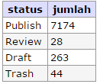

**Query**

SELECT COUNT(*) AS shared FROM post_shared WHERE created <= '2017-01-15 23:59:59';

**Output**



**Query**

SELECT COUNT(*) AS tag FROM post_tag WHERE created <= '2017-01-15 23:59:59';

**Output**



**Query**

SELECT COUNT(*) AS reaction FROM post_reactions WHERE created <= '2017-01-15 23:59:59';

**Output**



**Query**

SELECT CONCAT("Edisi ",volume) AS volume,created,shared,download FROM `magazine`;

**Output**

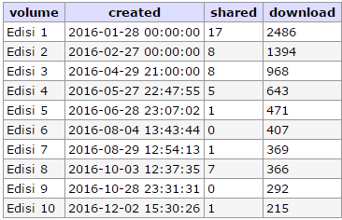

**Query**

SELECT pr.reaction, COUNT(*) AS jumlah

FROM post_reactions pr

WHERE pr.created BETWEEN '2017-01-09 00:00:01' AND '2017-01-15 23:59:59'

GROUP BY pr.reaction;

**Output**

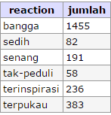

**Query**

SELECT r.name AS status, COUNT(*) AS jumlah

FROM post p

JOIN redaction_status r ON r.id = p.status

WHERE p.type IN (1,3,4) AND p.status IN (1,2,3,4) AND ( p.created BETWEEN '2017-01-09 00:00:01' AND '2017-01-15 23:59:59' )

GROUP BY p.status;

**Output**

